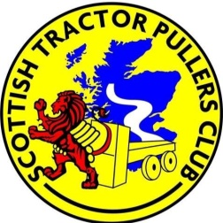

FARM CLASS TRACTOR PULLING RULES & ENTRY FORM Kirriemuir Show 15th July 2016

- Drivers must obey track staff instructions

- Tractors to be driven in a safe and courteous manner in pit area and on return road (maximum speed 10 mph)

- Tractors to be split into classes according to horse power

- Up to 200 hp
- 200 – 300 hp
- Over 300 hp

- No excessive ballast

- All tractors to pull in 2WD only

- Pull from pick-up hitch with adaptor link (provided)

- Anyone considered to be under the influence of alcohol or drugs will not be permitted to compete

- STPC committee decision is final

ENRTY FEE £10.00 PER CLASS

I agree to the above rules and conditions

Name............................... Tractor make & model................................................

Tractor reg. No............................... …. Signature.................................................

